GLIA ECG Build Documentation

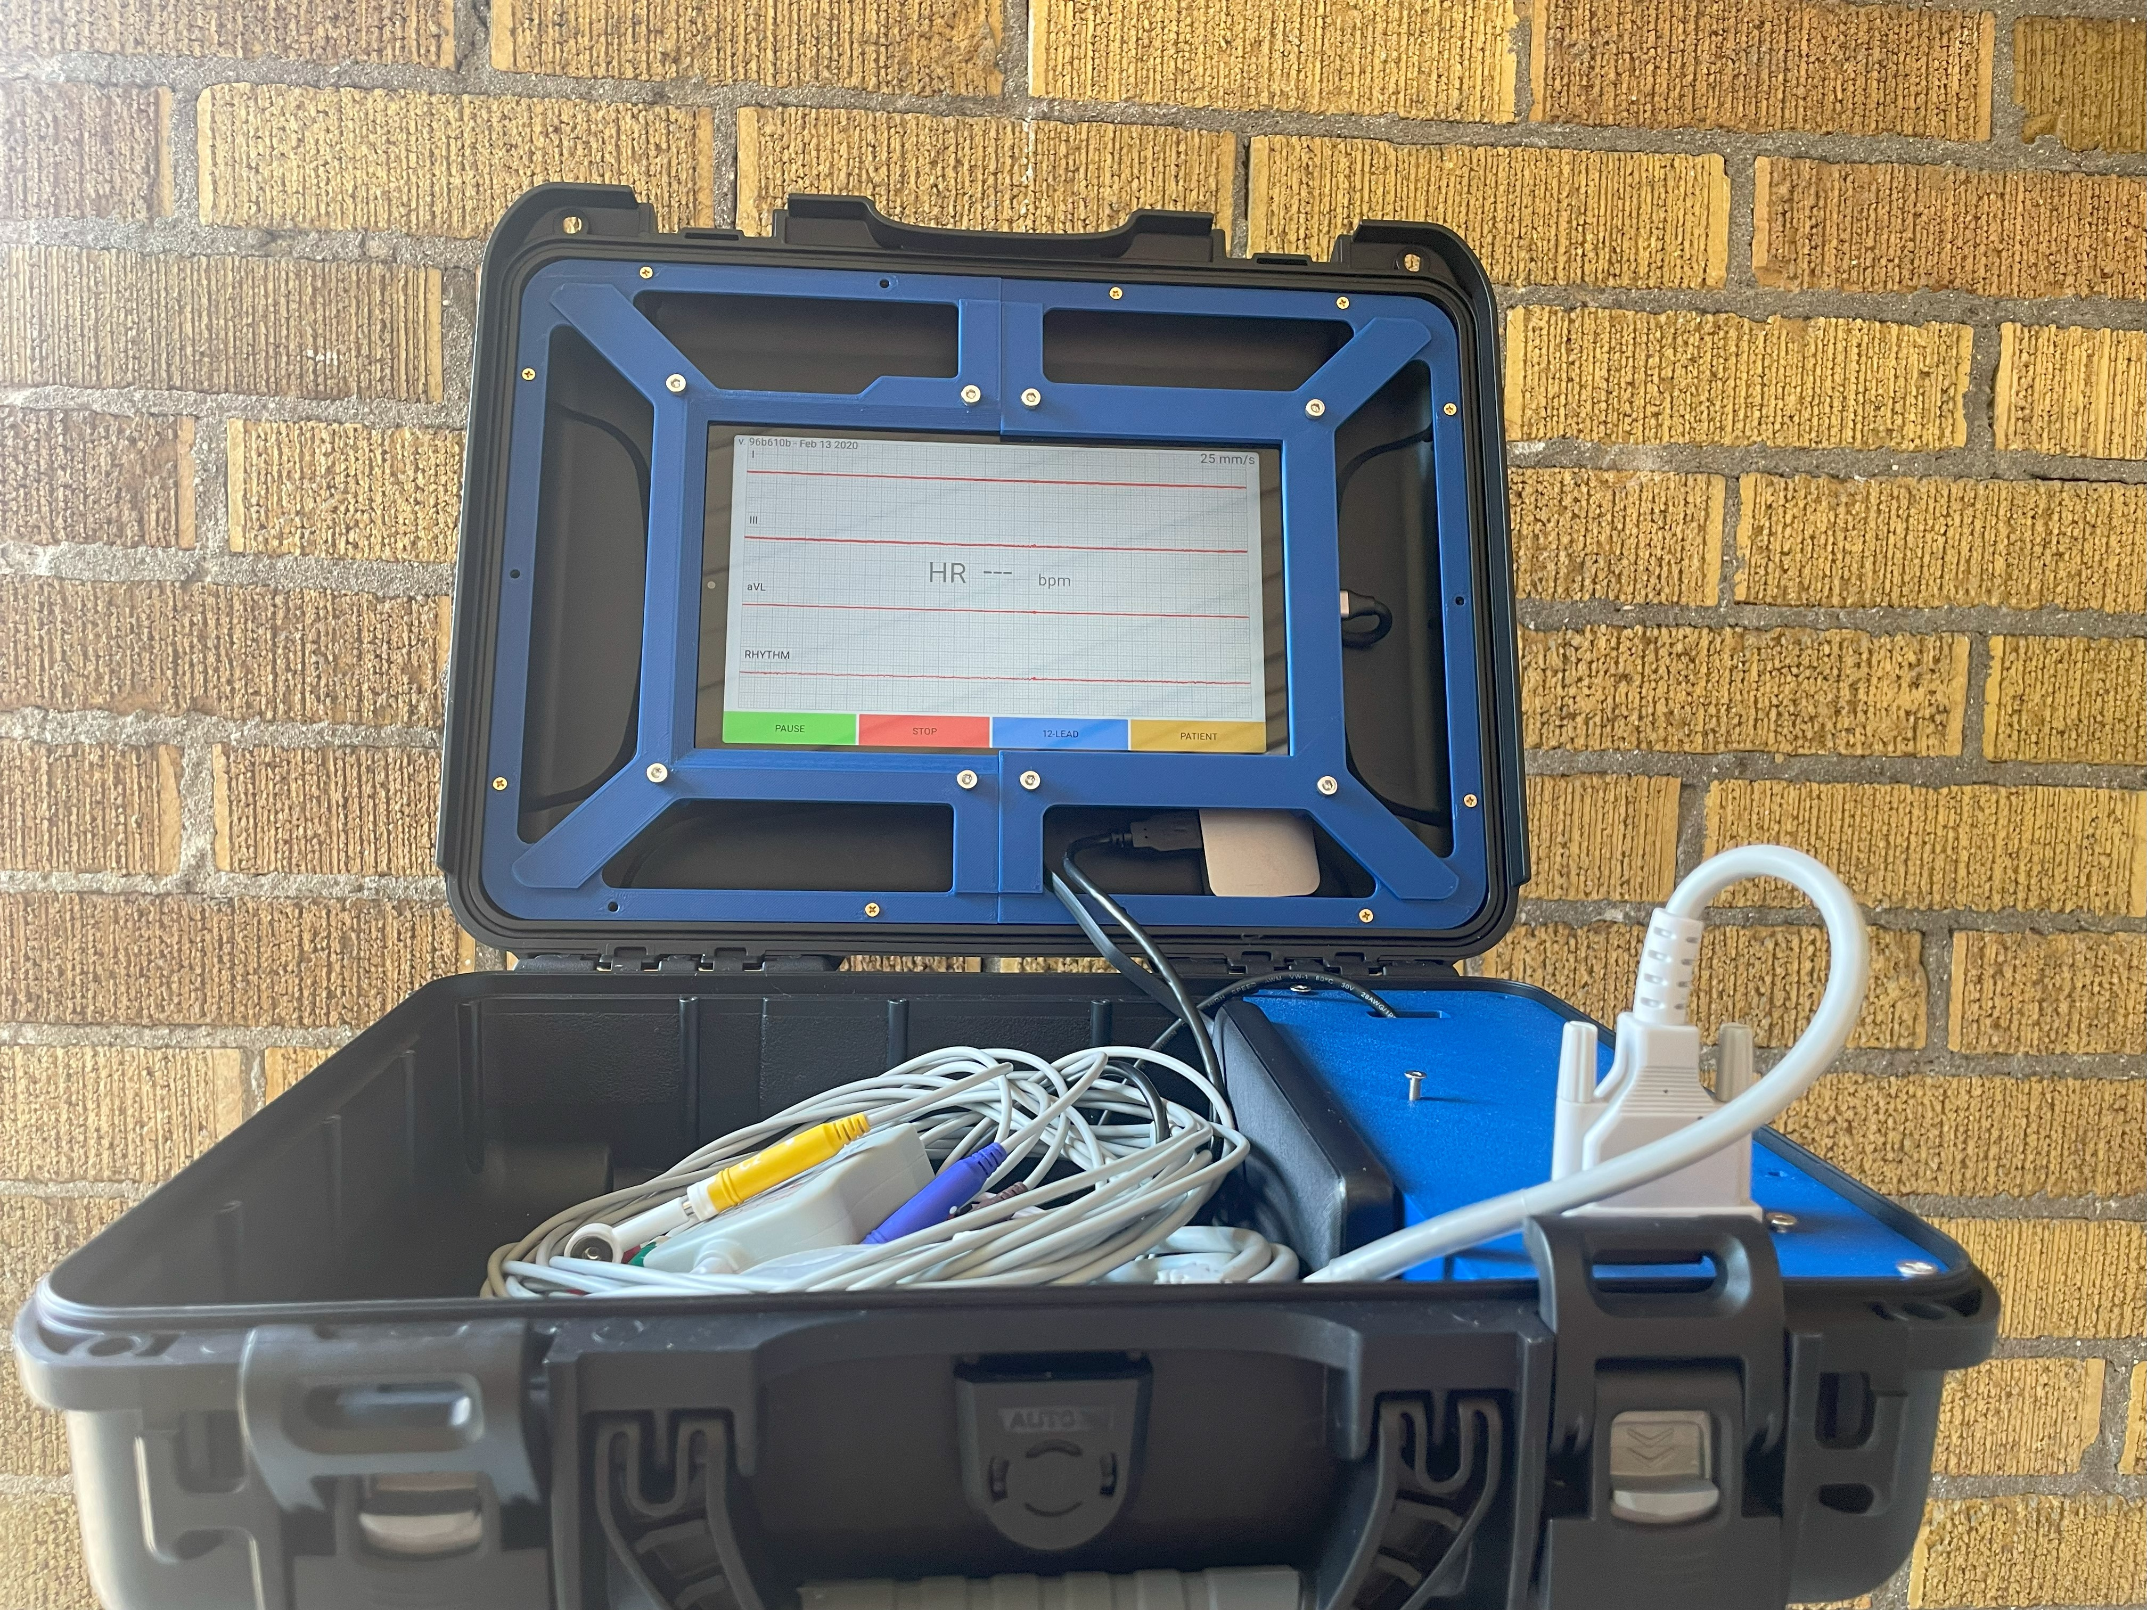

Table of Contents

Ordering PCB 2

Soldering additional components 5

Software 7

Tablet Housing 11

General Assembly 12

# Ordering PCB

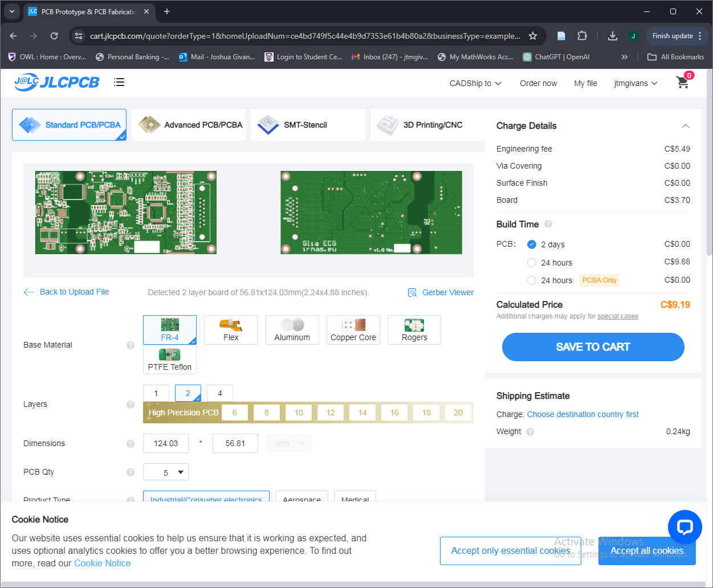

* Create an account with JLC PCB
* Upload [Gerber zip file](https://github.com/IRNAS/gliax-ecg-hardware/tree/250fb81300ce7d1ec355647e1b10f5446b7c7de5/release/gliax_ecg_simple/v1.0/Step%201%20-%20PCB%20Manufacturing)
* Check “PCB Assembly” at the bottom of the page. Click “Confirm”
* You will then be asked to upload a BOM file and CPL file to determine the components and component location on the board. The original BOM file found in the project folder is not formatted for external manufacturers, so a simplified format has been created and exported as an .xlsx file. The components remain identical. The BOM and CPL files can be found within the [documentation folder](https://github.com/GliaX/ecg/tree/master/Documentation) of this repository.

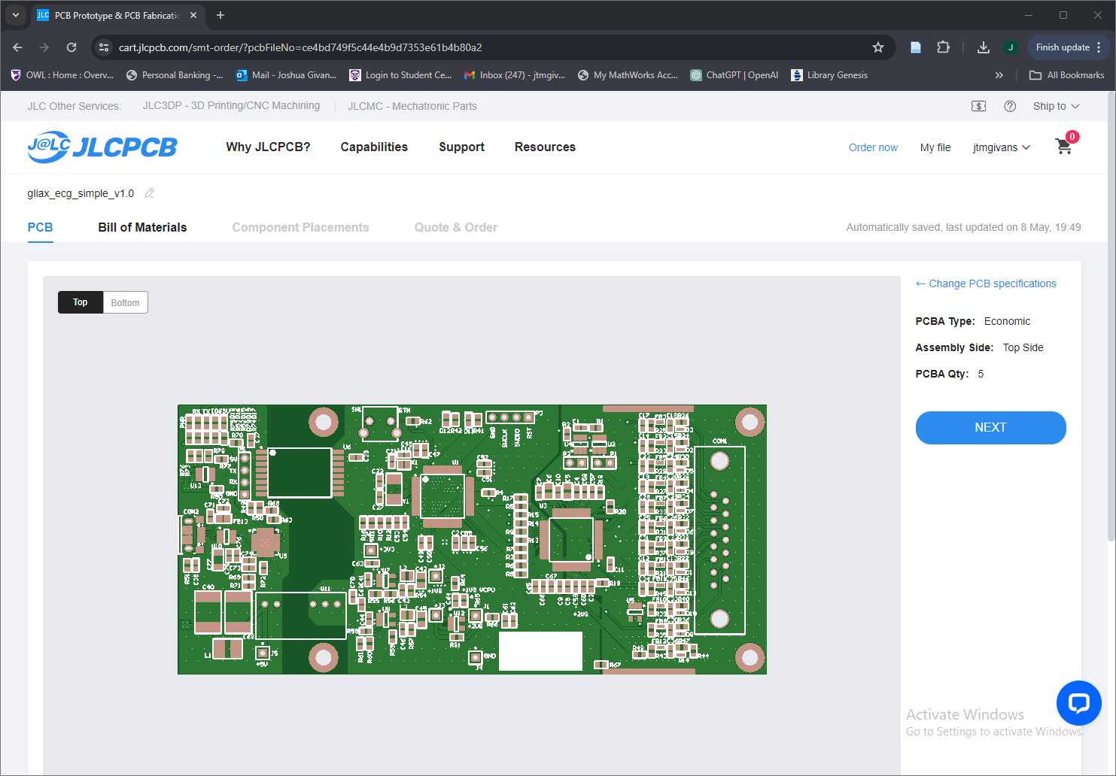

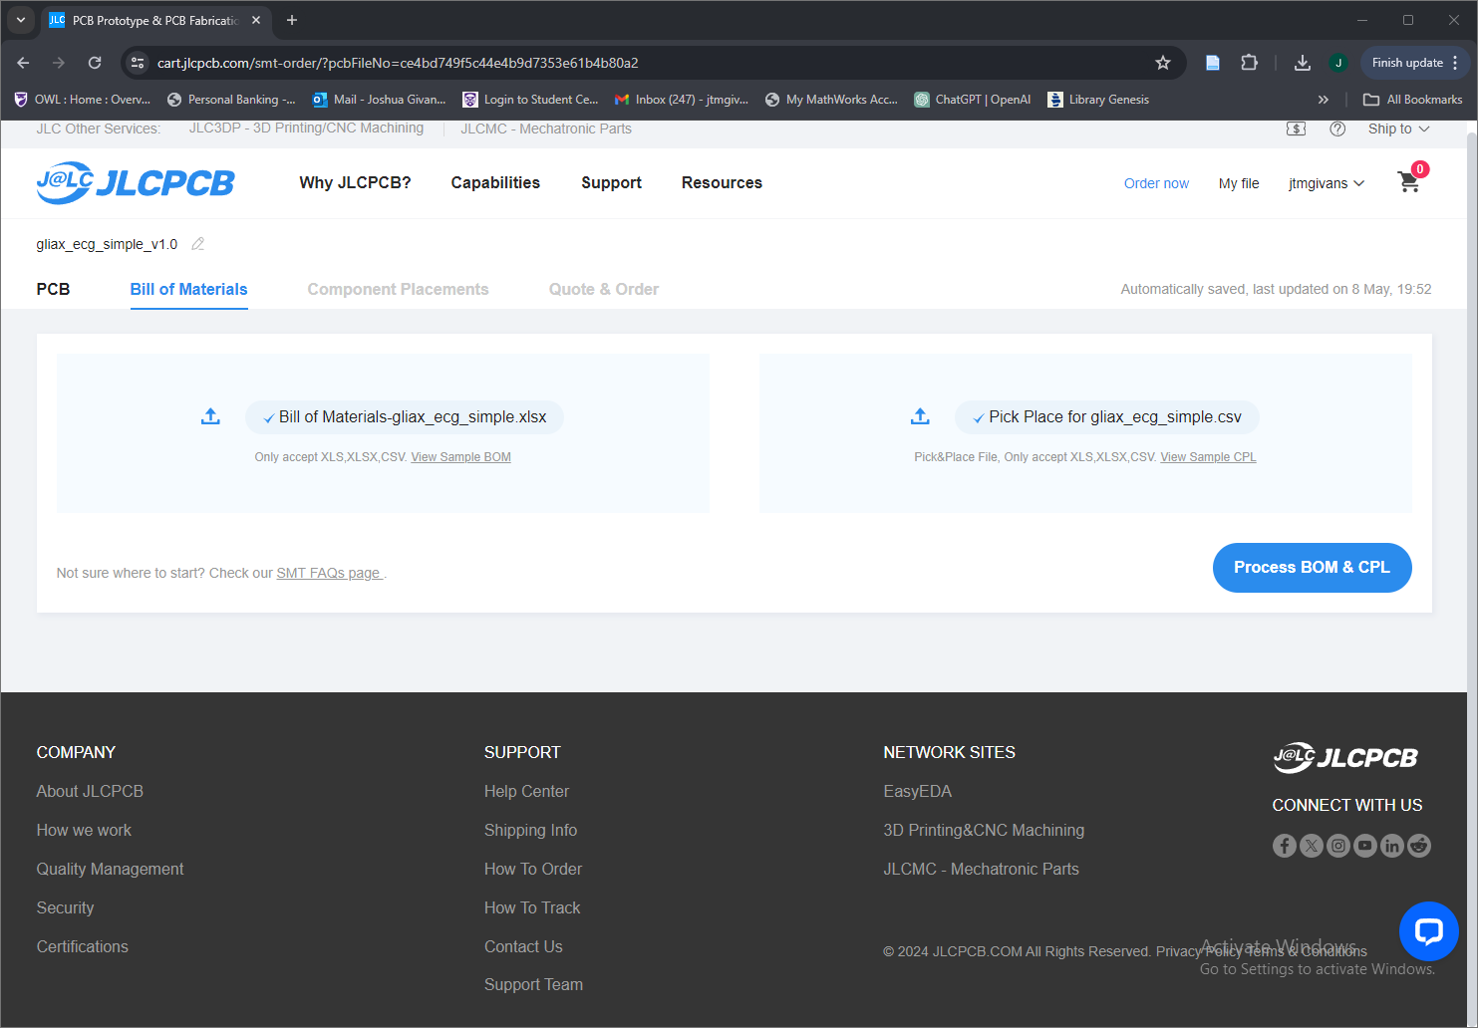

* Click “Process BOM and CPL”.

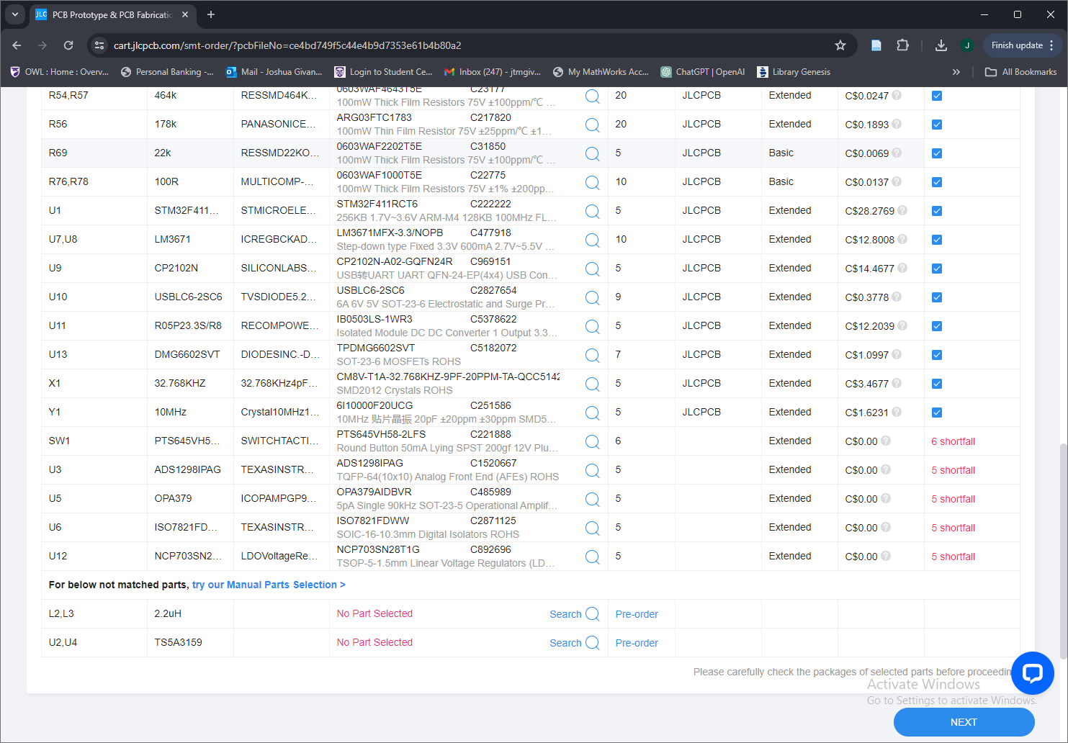

* JLCPCB will attempt to source all components. Some parts may have an inventory shortage and will be labeled as such at the bottom of the list. A good place to begin searching for missing components is <https://octopart.com/> . These components must be ordered separately and soldered to the board manually.
* **On production boards it is found that SW1, U7, R63, R80, R81 are not needed. These can either be excluded from the board upon order or removed when the board arrives.**
* Click “Next” and “Do Not Place” to ignore parts which are unavailable.
* Select “Next” to proceed and “Save to Cart”. Enter billing information to order.

# Soldering Additional Components

In some cases, the PCB manufacturer may not have certain components. It may be required to order them separately. The additional components in this case were: U6, U11, U12, CON 1, CON 2

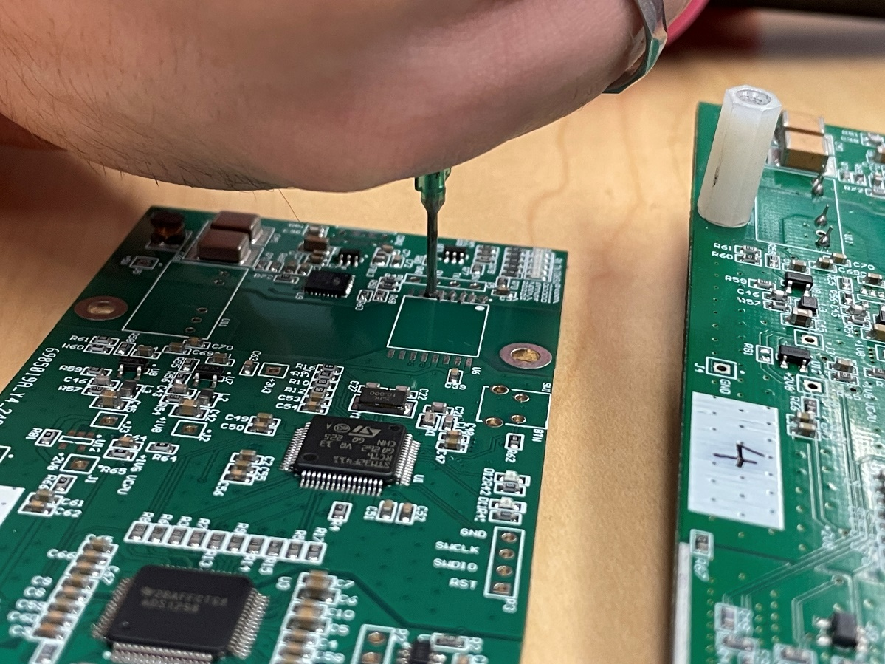

Solder paste and a heat gun were used to install the additional components to the board.

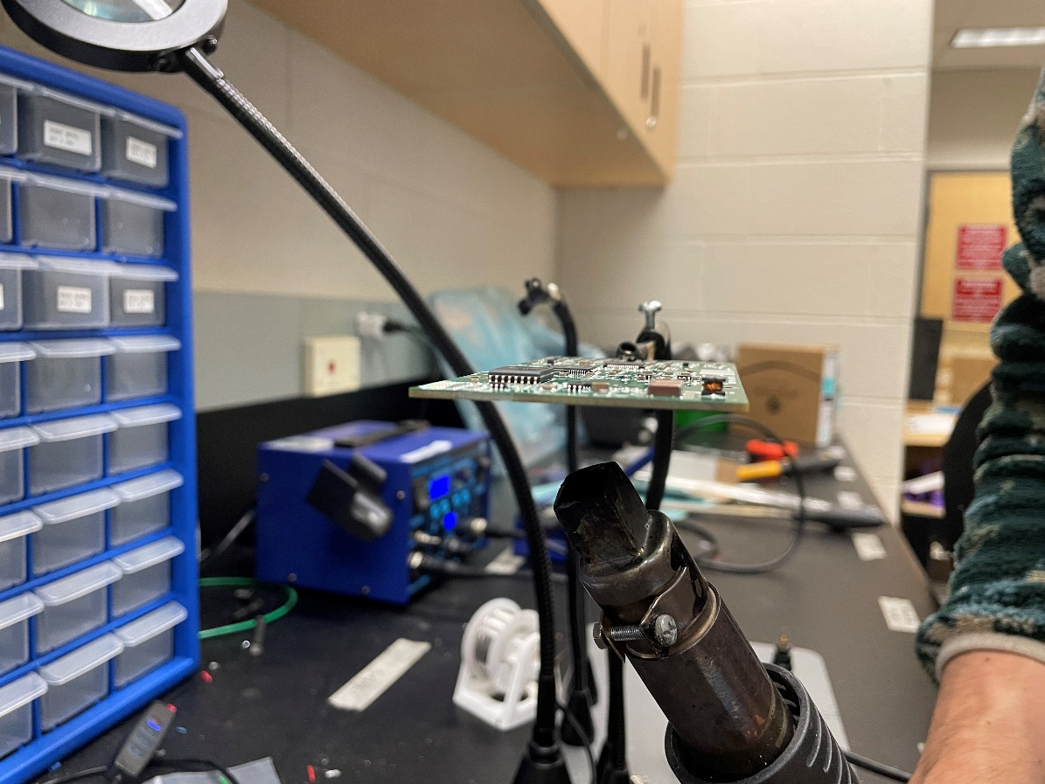

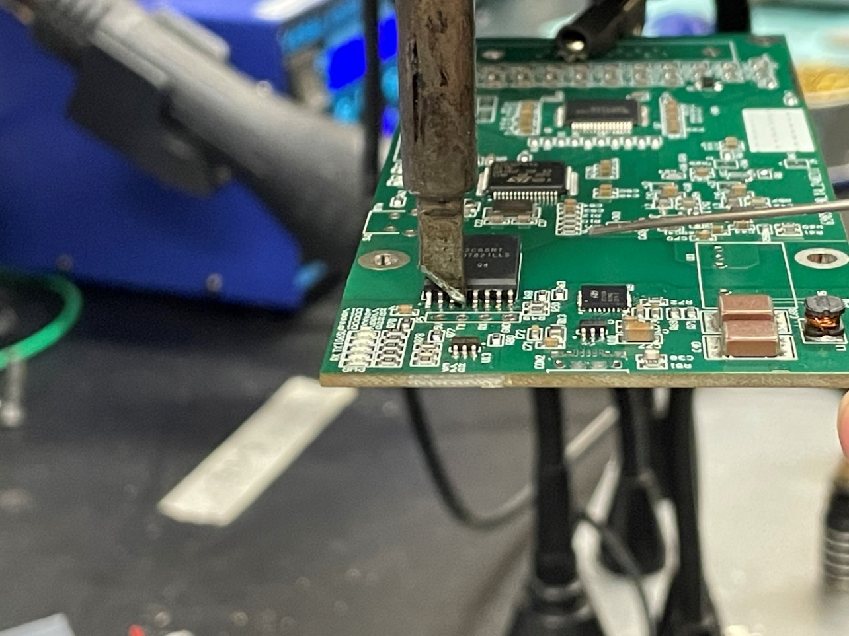

Also note that a jumper wire connects two pads on the back of the PCB as shown.

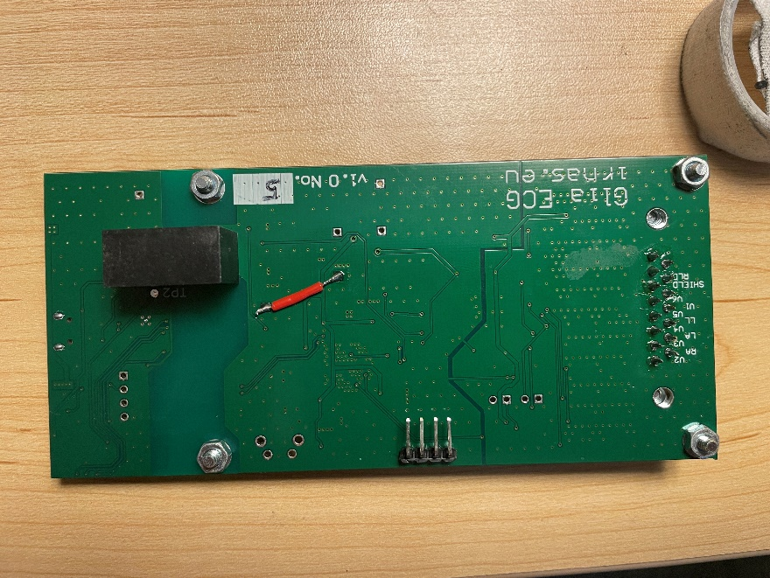

# Software

Android App

Download the APK file from the gliax-ecg-androd-application repository: <https://github.com/IRNAS/gliax-ecg-android-application/releases/tag/v1.1>

Upload the file to an android tablet using a USB cable.

Board Firmware

A [STLink inferface](https://www.digikey.ca/en/products/detail/stmicroelectronics/STLINK-V3SET/9636028?utm_adgroup=&utm_source=google&utm_medium=cpc&utm_campaign=PMax%20Product_Low%20ROAS%20Categories&utm_term=&productid=9636028&utm_content=&utm_id=go_cmp-20291741422_adg-_ad-__dev-c_ext-_prd-9636028_sig-Cj0KCQjw1qO0BhDwARIsANfnkv8_2Be6OCk6jWfsiBsO9ClWasryhsPS28UCqsdxhRD9VcvTw_L3_8AaAo0bEALw_wcB&gad_source=1&gclid=Cj0KCQjw1qO0BhDwARIsANfnkv8_2Be6OCk6jWfsiBsO9ClWasryhsPS28UCqsdxhRD9VcvTw_L3_8AaAo0bEALw_wcB) is required to upload firmware to the board. Off brand versions of the STLink exist but have not been verified to be compatible with this board.

Connect the serial wire in/out (SWDIO), Serial clock (SWCLK), ground (GND) and reset (RST) from the board to the defined pins on the STLINK. [See datasheet](https://www.st.com/resource/en/user_manual/um2448-stlinkv3set-debuggerprogrammer-for-stm8-and-stm32-stmicroelectronics.pdf) or Figure 1 for pinout diagram.

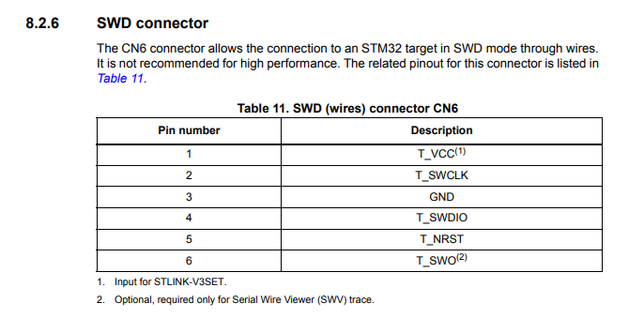

Figure 1 - SWD Pinout on STLink

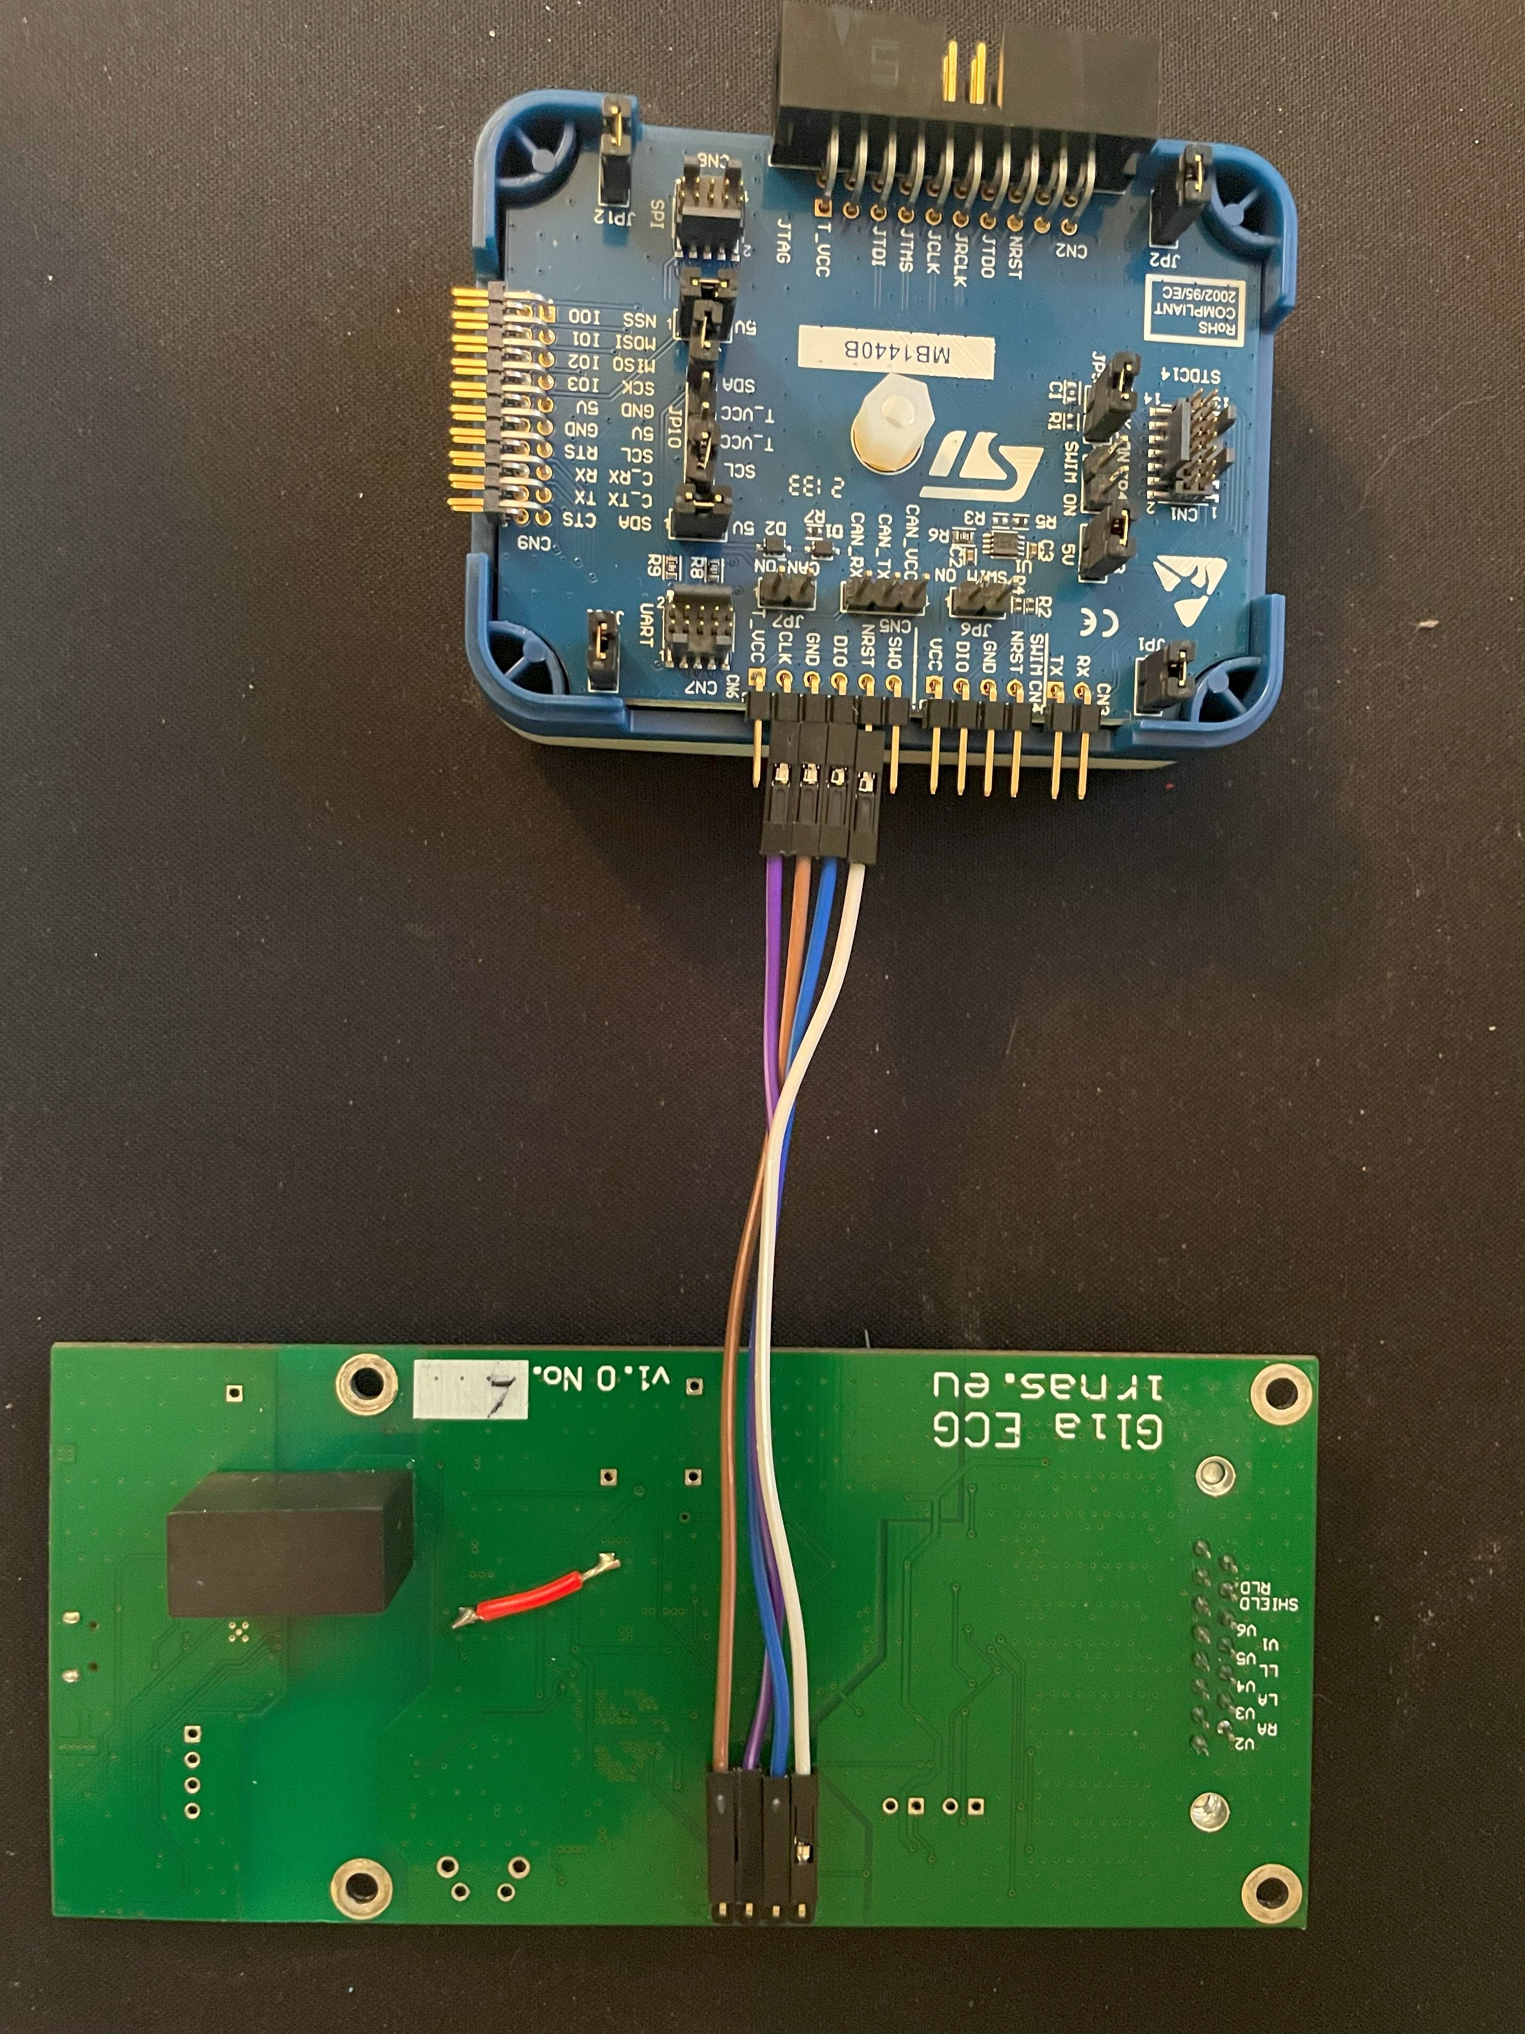

Figure 2 - STLink connected to ECG Board

Download the gliax-ecg-firmware-clean.bin file from the release page: <https://github.com/IRNAS/gliax-ecg-firmware/releases>

Download STM32CubeIDE:

<https://www.st.com/en/development-tools/stm32cubeide.html>

Once the STLink and ECG PCB are connected via the serial wire pins, power each of them through their respective USB ports. **NOTE**: for this process the STLink USB cable must be capable of both power and data transmission while the ECG USB cable only requires power.

Open STM32CubeIDE.

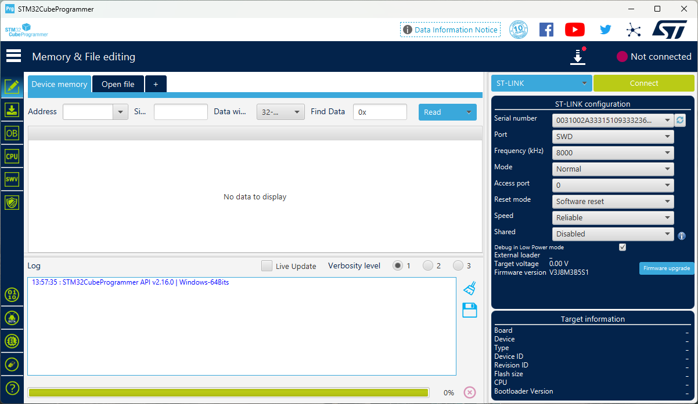

Select Connect in the top left corner. Once connected navigate to the “Erase & Program” tab. Select Browse and find the firmware .bin file.

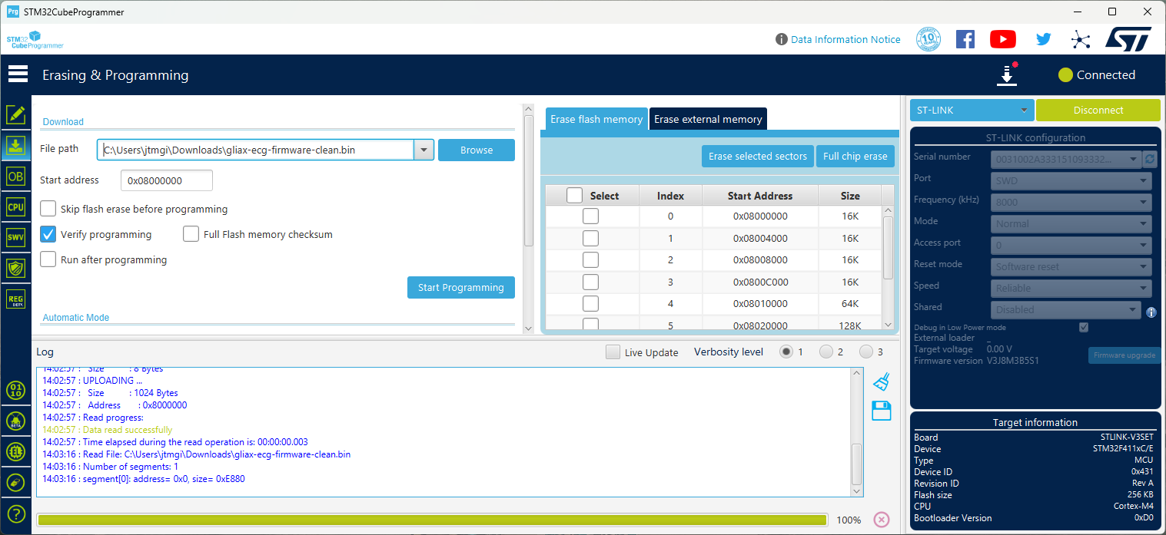

Select Start Programming.

Configuring ADC Chip

The CP2102N chip need to be configured as instructed in the GitHub repository: <https://github.com/IRNAS/gliax-ecg-firmware>. Download Simplicity Studio here: <https://www.silabs.com/developers/simplicity-studio>

* connect the board to PC with USB cable
* open Simplicity Studio and create new project (configure chip CP2102N revision: A02-new or A01-old chip)
* Open Port configuration: Serial
* Change pin GPIO5 both modes to Push-Pull and reset Latch to High
* Press Program to device
* ECG chip should turn on, which can be seen with LEDs blinking

# Tablet Housing

Download Case STL files from the repository. Slice with preferred slicer and settings below

|  |  |
| --- | --- |
| Filament Type | PLA + |
| Nozzle Size | 0.4mm |
| Nozzle Temp | 220 CO |
| Bed Temperature | 60 CO |
| First Layer Print Speed | 20mm/s |
| Print Speed | 40 – 80 mm/s |
| Layer Height | 0.24 mm |
| Brim | Not required |
| Infill | 15% |

Print each of the front panels.

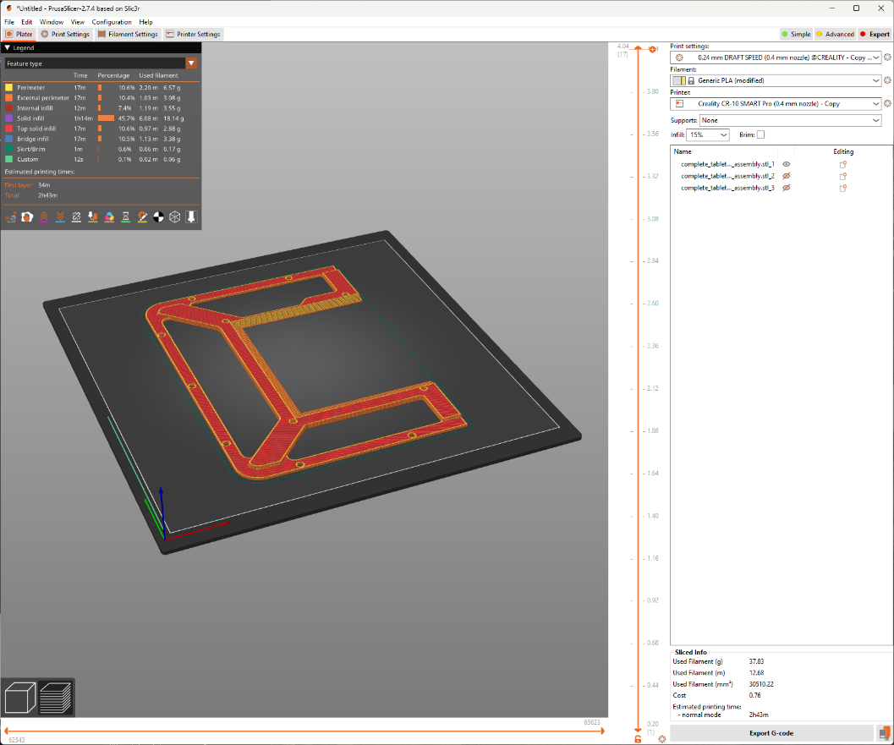

Print 1 tablet side frame.

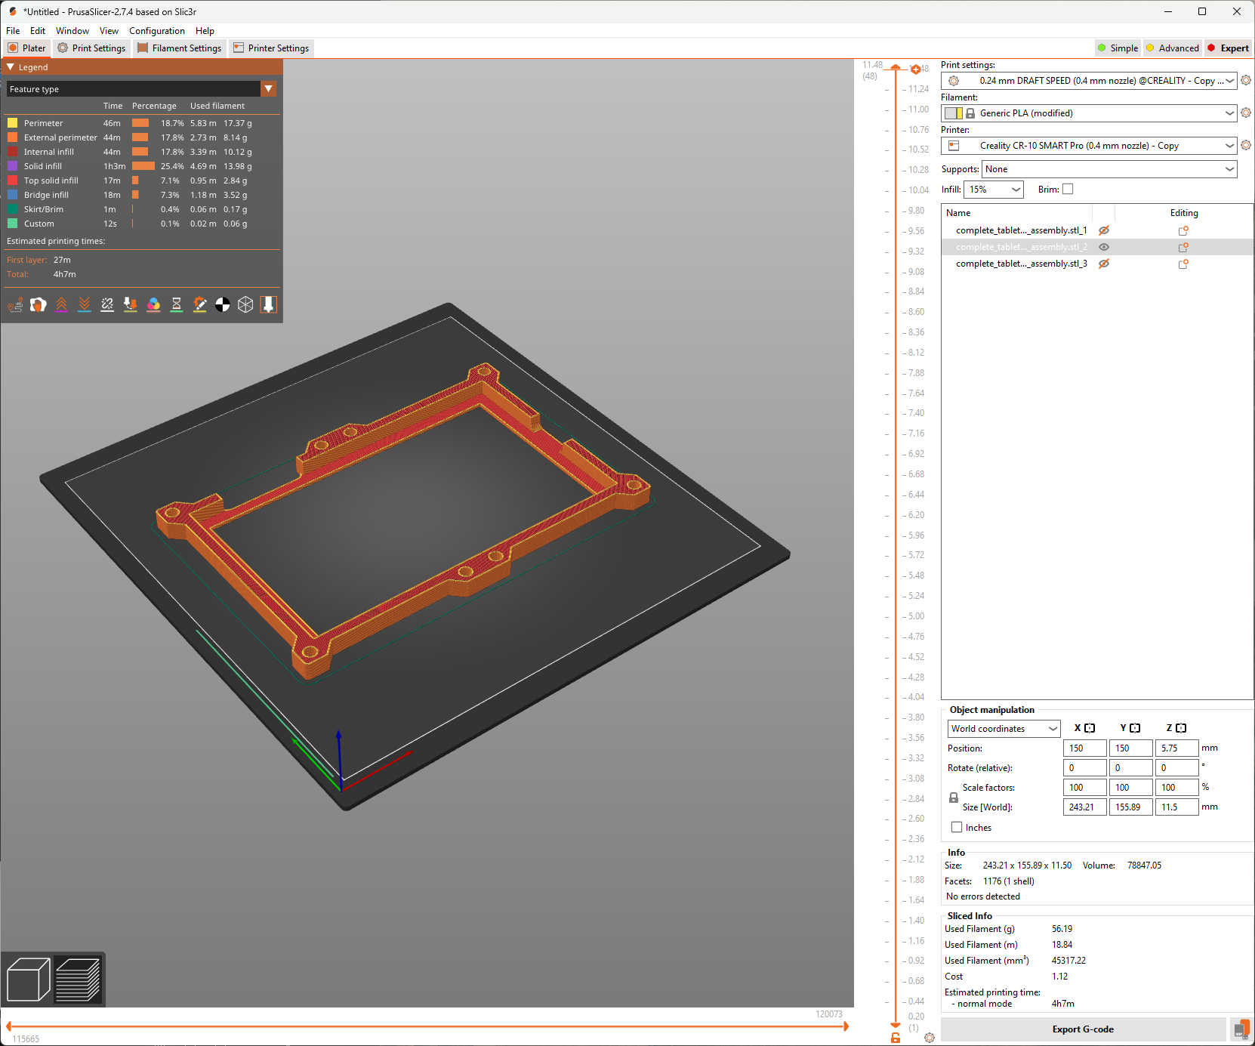

Print 1 PCB frame.

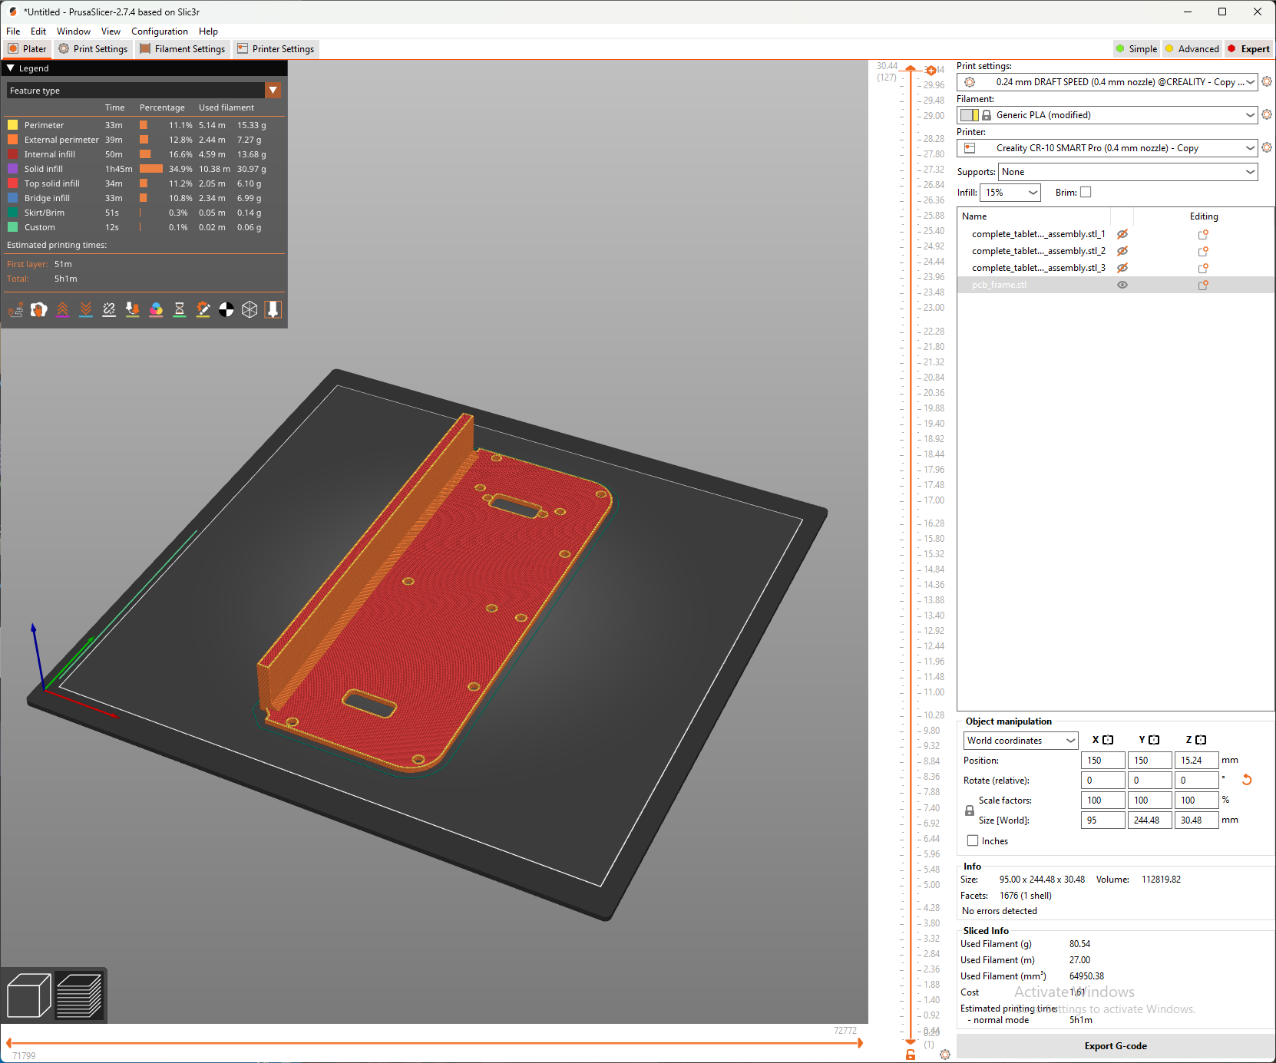

# General Assembly

The adapter that connects to the tablet needs to have a power pass through port such that the device can be charged though the adapter. Not all adapters have this feature - check before purchase.

First install the tablet within the frame structure using M4 x 8mm screws. Install the PCB within its frame using M3x6mm screws. Use self-tapping M2.5x12mm flat head screws to secure the tablet frame and PCB frame to the case.

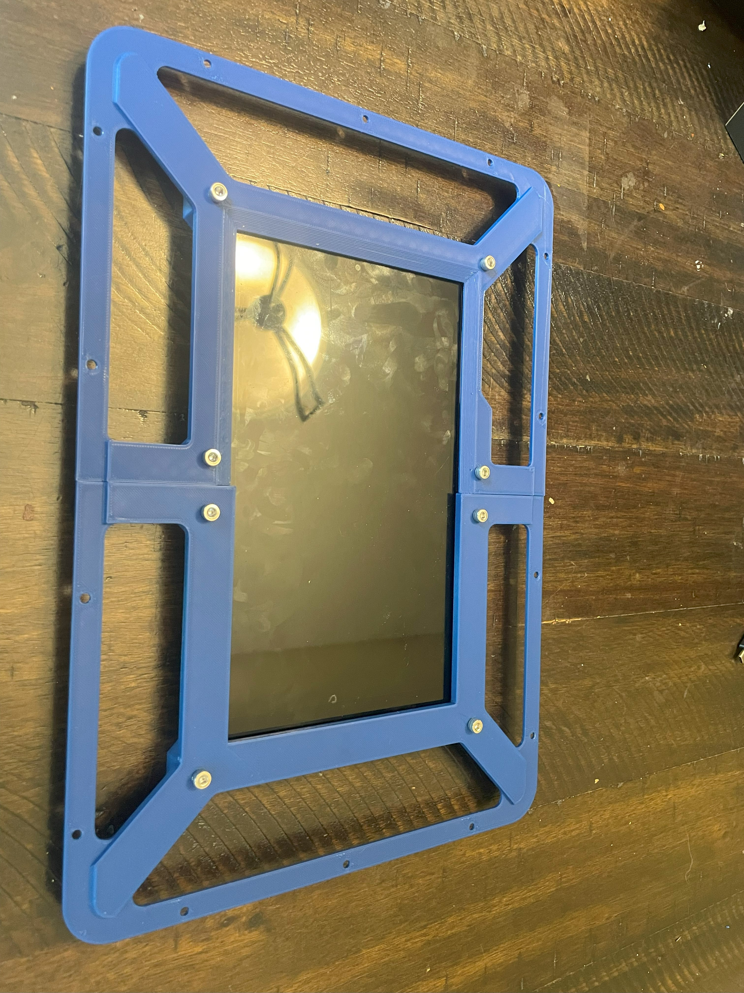

Place leads and battery bank in the case and test all components operate as expected.

